**

**UNIVERSITY-BANGLADESH**

**Assignment Cover Sheet**

|  |  |  |  |  |
| --- | --- | --- | --- | --- |
| Assignment Title: | **Drawing the proper electric Fittings and Fixture Layout based on a Civil plan using AutoCAD software and understanding BNBC** | | | |
| Assignment No: | **Experiment 7** | | Date of Submission: | **20-11-2022** |
| Course Title: | **Computer Aided Design & Drafting** | | | |
| Course Code: | **BAE2101** | | Section: D |  |
| Semester: | FALL | 2022-23 | Course Teacher: | **Dr. Md. Mahadi Hasan** |

**Declaration and Statement of Authorship:**

1. I/we hold a copy of this Assignment/Case-Study, which can be produced if the original is lost/damaged.
2. This Assignment/Case-Study is my/our original work and no part of it has been copied from any other student’s work or from any other source except where due acknowledgement is made.
3. No part of this Assignment/Case-Study has been written for me/us by any other person except where such collaboration has been authorized by the concerned teacher and is clearly acknowledged in the assignment.
4. I/we have not previously submitted or currently submitting this work for any other course/unit.
5. This work may be reproduced, communicated, compared and archived for the purpose of detecting plagiarism.
6. I/we give permission for a copy of my/our marked work to be retained by the Faculty for review and comparison, including review by external examiners.
7. I/we understand that Plagiarism is the presentation of the work, idea or creation of another person as though it is your own. It is a formofcheatingandisaveryseriousacademicoffencethatmayleadtoexpulsionfromtheUniversity. Plagiarized material can be drawn from, and presented in, written, graphic and visual form, including electronic data, and oral presentations. Plagiarism occurs when the origin of them arterial used is not appropriately cited.
8. I/we also understand that enabling plagiarism is the act of assisting or allowing another person to plagiarize or to copy my/our work.

*\* Student(s) must complete all details except the faculty use part.*

** Please submit all assignments to your course teacher or the office of the concerned teacher.

|  |  |  |  |  |
| --- | --- | --- | --- | --- |
| **No** | **Name** | **ID** | **Program** | **Signature** |
| 1 | Alam, Md. Shohanul | 12-22494-3 | **CSE** |  |
|  |  |  |  |  |

|  |  |  |
| --- | --- | --- |
| ***Faculty use only*** | | |
| FACULTYCOMMENTS | **Marks Obtained** |  |
|  |
|  |
|  | **Total Marks** |  |
|  |
|  |

**Objective:**

To familiarize students with proper understanding of drawing electric fittings and  
fixture distribution based on civil planning using AutoCAD software. Moreover, another  
objective of this experiment is the practical safeguarding of persons, and of buildings and their contents from electrical hazards. The experiment also constitutes minimum standards for electric wiring and equipment installed within or on public and private buildings and other premises.

**Symbols List:**

F – Fan  
L – Light  
T – Tube Light  
K – One Kind of Light  
TV – Television  
TE – Telephone  
M – Motor  
CH – Hanging Light  
ML – Multiple Light  
CB – Circuit Breaker  
SB – Switch Board  
SS – Switch Board Socket  
ST – Two Pin Socket  
SL – Skirting Level Socket  
TS – TV Socket  
15_1 – 3 Pin Socket (15 A)  
TJB – Telephone Junction Board;  
AJB – Antenna Junction Board  
C1, C2.... – No of Cables;  
1,2,3......... – No of SB  
SDB – Sub Distribution Board,  
MDB – Main Distribution Board

**Discussion and Conclusion:**

The drawing was done using the AutoCAD software. First of all, the floor plans were drawn. While drawing I faced some difficulties with the measurements as they were missing in the sample drawing. But after analyzing the sample drawing, I came to know that most of the room sizes are identical and then it became easier to make the drawing. So used previous experiences and done some parallel calculations for drawing the rooms.

After the completion, followed the sample drawing and added all the components. Different components are used in the drawing and they were used more than once. So before placing those components I prepared every required component drawing separately and later on made copy and pasted according to the position. Some of the components are positioned at center of the room so those measurements were also done before placing the components.

Among some of the components, they are placed according to the room position. So, I used the rotate option and changed the components to match the sample drawing components and then placed them accordingly. And later on, for each component, used the symbol naming according to the sample drawing using the text option.

The main challenge of the task was drawing different components and placing them in the right position. There were many components, so this drawing took a large time to finish. If the components were previously drawn or saved the drawing task could have been easier.

**AutoCAD Drawing Image:**

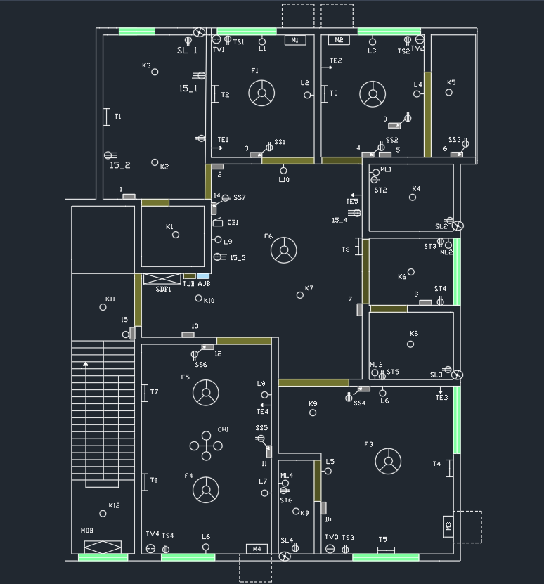

**References:**

1. Kristen S. Kurland, “AutoCAD 2004, 2D Training Manual”.  
2. Bob McFarlane, “Beginning AutoCAD 2004”.  
3. David Byrnes and Mark Middlebrook, “AutoCAD 2007 For Dummies”.  
4. Bangladesh National Building Code (BNBC) – 1993, part 8.